**SALESFORCE INTERNSHIP PROJECT REPORT**

**Project Title:**

HandsMen Threads – Elevating the Art of Sophistication in Men's Fashion  
**Internship Organization:**

SmartBridge (Salesforce Track)  
**Institution Name:**

SRM University AP

**Student Name:** Ganta.Rajesh  
**Program & Department:** B.Tech, CSE  
**Internship Duration:** 2Months

**1. Introduction**

This report outlines the Salesforce internship project undertaken as part of the academic curriculum at SRM University AP, in collaboration with SmartBridge under the Salesforce Developer track. The objective of this internship was to gain practical exposure to cloud-based CRM platforms and apply theoretical knowledge to real-world business problems.

The project, titled HandsMen Threads – Elevating the Art of Sophistication in Men's Fashion, focuses on developing a customized Salesforce solution for a premium men's fashion brand. The brand aims to offer high-quality bespoke tailoring and styling services. Our Salesforce implementation was designed to streamline business operations, improve customer relationship management, and automate workflows across various departments such as sales, inventory, and customer support.

By using Salesforce tools like custom objects, flows, Apex triggers, dashboards, and role-based access control, the project showcases how technology can enhance traditional business models and deliver an efficient and user-friendly experience for both employees and customers.

**2. Project Objective**

The main goal of this project is to design, build, and implement a comprehensive CRM solution on the Salesforce platform tailored for a fashion-focused business model. The key objectives include:

* To develop a scalable and customizable Salesforce-based CRM system for a premium men's fashion brand, enabling better customer service and streamlined operations.
* To capture and manage data related to customers, employees, inventory, products, and orders using custom objects and data models within Salesforce.
* To automate business processes such as order assignment, loyalty status updates, and low-stock alerts through the use of Record-Triggered Flows, Apex logic, and email notifications.
* To establish role-based security and data access using profiles, roles, and permission sets tailored to different user groups like Sales Executives, Inventory Managers, and Servers.
* To design and build interactive dashboards and reports for performance tracking, decision-making, and business intelligence insights.
* To gain hands-on experience with real-time use cases, thereby applying Salesforce skills in configuration, development, and deployment in a live business scenario.

Through this project, we aimed not only to address the practical needs of the business but also to enhance our understanding of CRM strategies, Salesforce architecture, and enterprise-level application development.

3. **Use Case:**

**Salesforce Implementation for HandsMen Threads**

**Overview**

This use case section highlights the business processes automated using Salesforce through the custom object **HandsMen_Order__c**, designed to streamline order management, enhance customer interaction, and improve internal efficiency for HandsMen Threads.

**Use Case 1: Automated Order Confirmation**

* **User Roles Involved:** Customer, Sales Executive, Salesforce System
* **Preconditions:** A new HandsMen_Order__c record is created.
* **Trigger:** A sales executive creates a new order.

**Main Flow:**

1. Sales Executive logs a new order using HandsMen_Order__c.
2. A flow is triggered that sends a confirmation email to the customer's registered email address.
3. Order details (customer, items, date, total) are saved and linked to the HandsMen_Customer__c record.
4. Email activity is logged for audit and communication tracking.

**Outcome:**

Customer receives immediate confirmation, enhancing trust and experience.

**Use Case 2: Dynamic Loyalty Program**

* **User Roles Involved:** Customer, Salesforce System
* **Preconditions:** Customer must have existing HandsMen_Order__c records.
* **Trigger:** A new order is created or an existing order is updated.

**Main Flow:**

1. Salesforce Flow retrieves the total value of all orders linked to a customer.
2. Based on defined thresholds, the Loyalty_Status__c field on the HandsMen_Customer__c object is updated (e.g., Bronze, Silver, Gold).
3. Status changes may trigger email notifications or special offers.

**Outcome:**

Loyal customers are rewarded automatically, increasing retention and personalized engagement.

**Use Case 3: Proactive Stock Alerts**

* **User Roles Involved:** Inventory Manager, Salesforce System
* **Preconditions:** Product and inventory are tracked using Inventory__c with Stock_Quantity__c.
* **Trigger:** A product's stock falls below the threshold after order placement.

**Main Flow:**

1. A record-triggered flow watches Stock_Quantity__c in Inventory__c.
2. When quantity < 5, Salesforce sends an automatic alert email to the Inventory Manager or Warehouse Team.
3. The email includes SKU, Product Name, and remaining quantity.

**Outcome:**

Team is notified to reorder before items go out of stock, maintaining operational efficiency.

**Use Case 4: Scheduled Bulk Order Updates**

* **User Roles Involved:** Salesforce System (Batch + Scheduler), Finance/Admin Team
* **Preconditions:** Orders exist in the HandsMen_Order__c object.
* **Trigger:** A scheduled batch process runs daily at midnight.

**Main Flow:**

1. The Apex scheduler activates a batch job that processes all HandsMen_Order__c records from the past day.
2. Financial totals are updated and inventory is adjusted based on ordered items.
3. Summary reports are updated and shared with the management team.

#### **Outcome:**

Real-time reporting accuracy and operational readiness for the next business day.

**4. USER STORY:**

**4.1**

**Phase 1: Architecture & Planning**

This phase focused on analyzing business requirements and translating them into a scalable Salesforce architecture.

* Defined custom objects (e.g., HandsMen_Order__c, Inventory__c, Product__c, Employee__c, Customer__c).
* Established relationships (Lookup and Master-Detail).
* Designed key fields including formula fields and roll-up summaries.
* Created validation rules to ensure data quality.
* Planned automation processes using:
  + Record-triggered flows
  + Apex triggers
  + Batch jobs for scheduled processing
* Designed email templates for:
  + Order confirmation
  + Stock alerts
  + Loyalty status updates

**Phase 2: Development**

This phase involved the actual configuration and customization within Salesforce.

* Created all necessary custom objects and fields.
* Implemented automation:
  + Flows for order confirmation, loyalty updates, and inventory alerts.
  + Process Builders (where applicable).
  + Apex triggers for dynamic logic.
* Developed batch Apex jobs for scheduled midnight processing of bulk orders.
* Configured field-level security, object permissions, roles, and sharing rules.
* Integrated email templates with automation tools.

**Phase 3: Testing & Quality Assurance**

This phase ensured functional correctness and system reliability.

* Performed unit testing on:
  + Flows
  + Triggers
  + Batch jobs
* Conducted end-to-end testing using sample test data.
* Validated automation logic with edge cases.
* Conducted security testing (role-based visibility, field accessibility).
* Ensured scalability and response time under expected user load.

**Phase 4: Deployment & User Training**

This phase focused on production rollout and user adoption.

* Migrated the solution from sandbox to production using change sets.
* Provided walkthrough sessions and training materials for:
  + Sales consultants
  + CRM managers
  + Inventory staff
* Established post-go-live monitoring:
  + Tracking system logs
  + Debugging any live issues
  + Ensuring smooth user experience

**ERD Diagram**

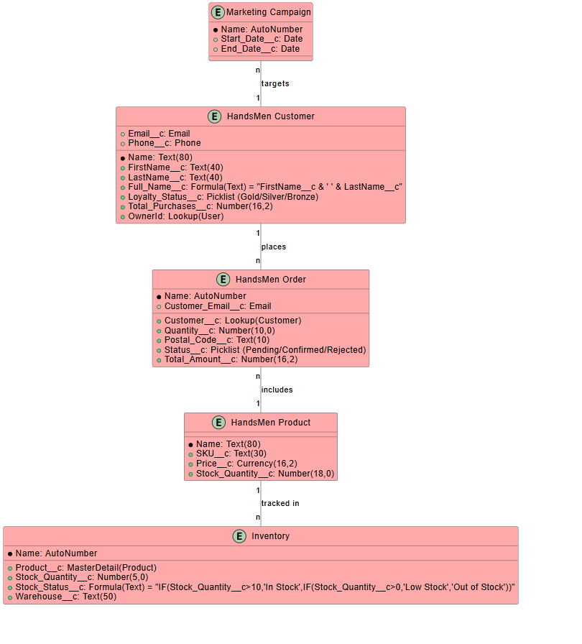

**Object Model:**

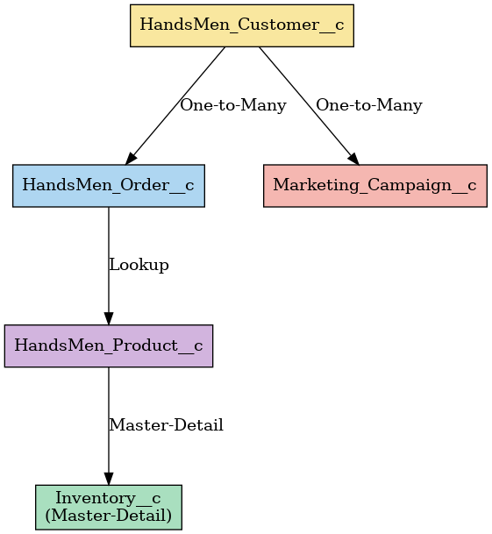

**4.2 Automation Strategy – HandsMen Threads**

The Salesforce automation strategy for the HandsMen Threads project is designed to streamline customer interactions, order management, inventory control, and campaign communication through the use of Flows, Apex Triggers, Scheduled Batch Jobs, and Email Alerts.

**Flow Automations**

**Loyalty Status Flow:**

This is a record-triggered flow activated when an order's status changes to "Delivered." It fetches the associated customer record, calculates their total purchase value, and updates the loyalty status accordingly. If the total is ₹5000 or more, the status is updated to Gold. If it falls between ₹2500 and ₹4999, it's updated to Silver. Any value below ₹2500 assigns a Bronze status. This encourages repeat purchases and helps in segmenting customers based on value.

**Stock Alert Flow:**

**This automation is triggered when a record in the Inventory object is updated and the stock quantity drops below five units. The flow automatically updates the stock status to "Low Stock" and sends a real-time alert to the warehouse team. This ensures timely restocking and prevents order delays due to stockouts.**

**Order Confirmation Flow:**

**After an order is marked as "Confirmed", a flow sends an automatic confirmation email to the customer. This enhances transparency and keeps the customer informed, improving the overall service experience.**

**Trigger Logic**

Apex triggers were implemented in the HandsMen Threads Salesforce CRM to automate real-time operations that couldn't be handled by declarative tools like flows alone. These triggers ensure data consistency, operational efficiency, and seamless workflow execution.

**Order Trigger:**

An Apex trigger is configured on the HandsMen Order object. Whenever a new order is inserted or an existing one is updated to “Delivered”, the system calls a handler class that recalculates the customer's total purchase value and updates their loyalty status. This ensures the customer's engagement tier is always up to date in real time.

**Product Trigger :**

This optional trigger ensures that stock quantity for a product never falls below zero. It can also be extended to automatically sync the product's inventory level with related records, preventing data mismatch and improving inventory accuracy.

**Batch Job Schedules**

The project includes scheduled Apex batch jobs for nightly processing of data. One job updates inventory records and sends alerts for low stock situations at midnight each day. Another batch job recalculates customer spending totals and ensures that loyalty statuses and financial summaries are up-to-date. These jobs are scheduled using the Apex scheduler and run automatically at defined intervals.

**Email Alert Strategy**

Email alerts are integrated throughout the system to keep stakeholders informed at every stage. Customers receive confirmation emails after placing orders and can also be notified when their loyalty tier changes. The warehouse team receives alerts when stock is low. Additionally, marketing users can be notified about upcoming campaign start dates. These alerts are triggered either via flows or scheduled processes, ensuring timely communication without manual intervention.

**5. Data Management - Objects**

**5.1 Object - HandsMen Customer:**

The HandsMen_Customer__c object is designed to store detailed information about customers who engage with the HandsMen Threads fashion platform. This object serves as the foundation for all customer-related interactions in the system, supporting features like order history tracking, loyalty management, and personalized marketing.

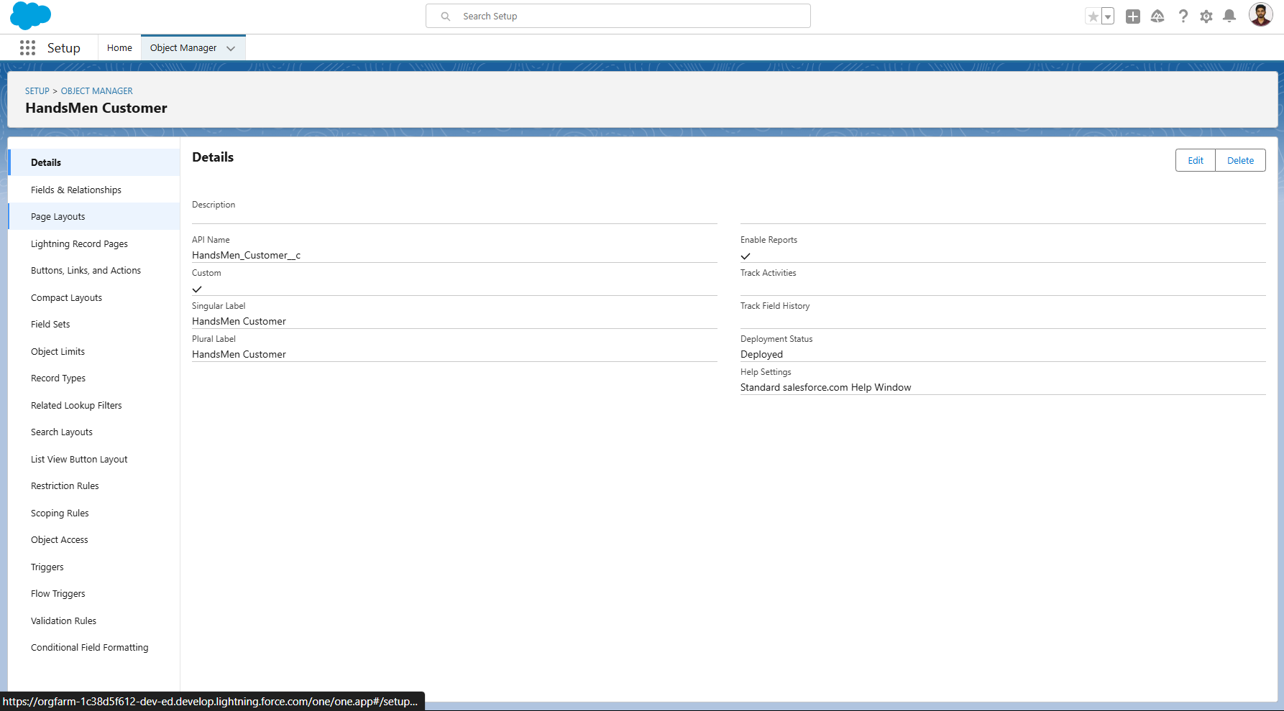

**5.2 Object - HandsMen Product:-**

The HandsMen_Product__c object represents the catalog of fashion products offered by HandsMen Threads. It is central to managing inventory, pricing, product tracking, and stock-related automations**.**

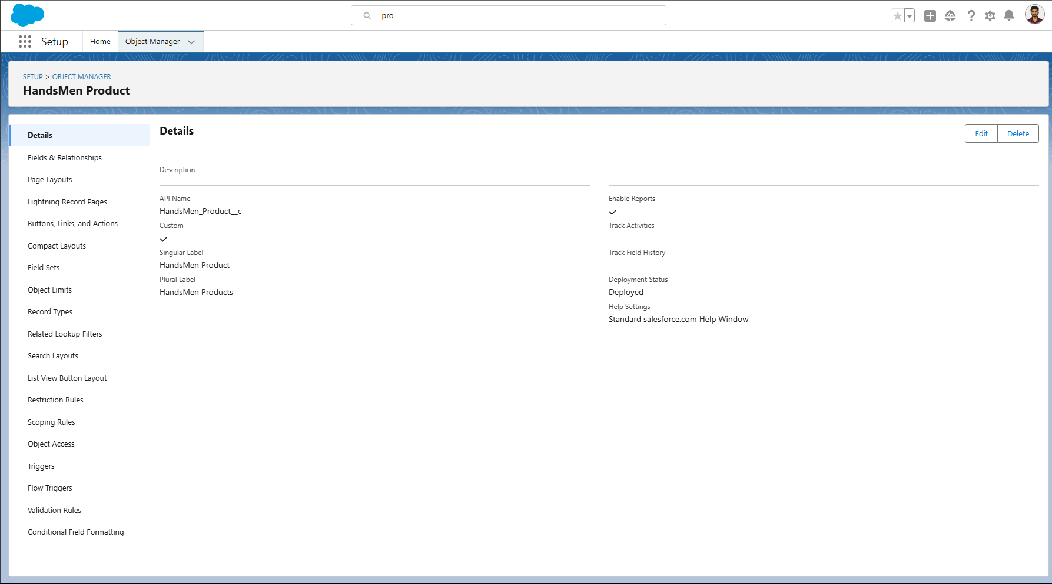

**5.3 Object - HandsMen Order:-**

The HandsMen_Order__c object is designed to manage all order-related information within the HandsMen Threads fashion CRM system. It acts as the core transactional object that links customers to their purchases and tracks fulfillment, status, and total value.

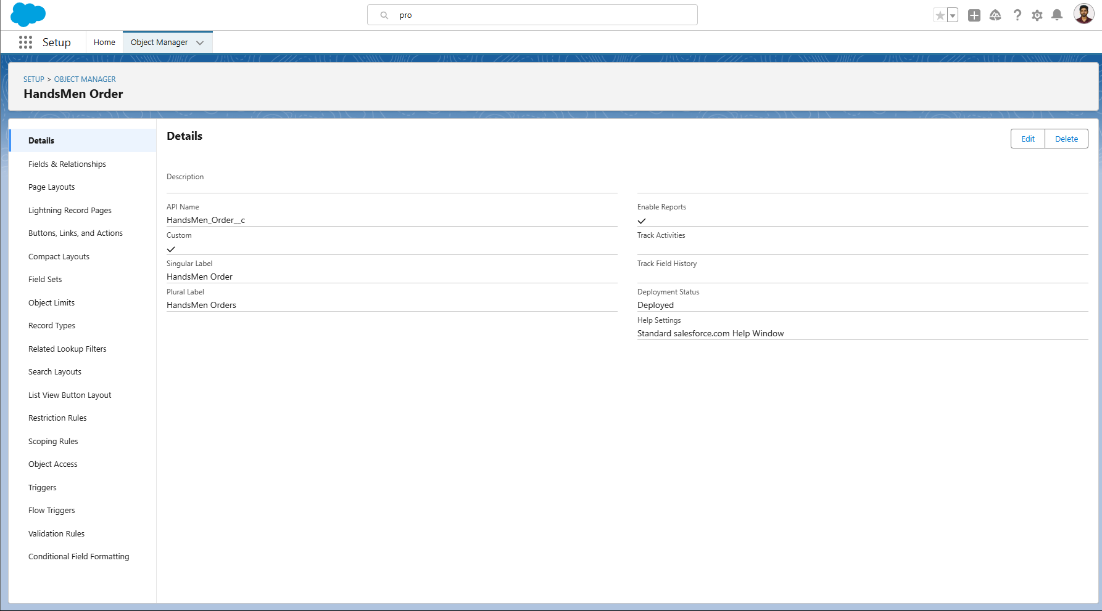

**5.4 Object - Inventory :-**

The Inventory__c object is used to manage and track the availability of products across different warehouse locations within the HandsMen Threads platform. It is directly tied to product stock monitoring and supports automation processes like low stock alerts and batch stock updates.

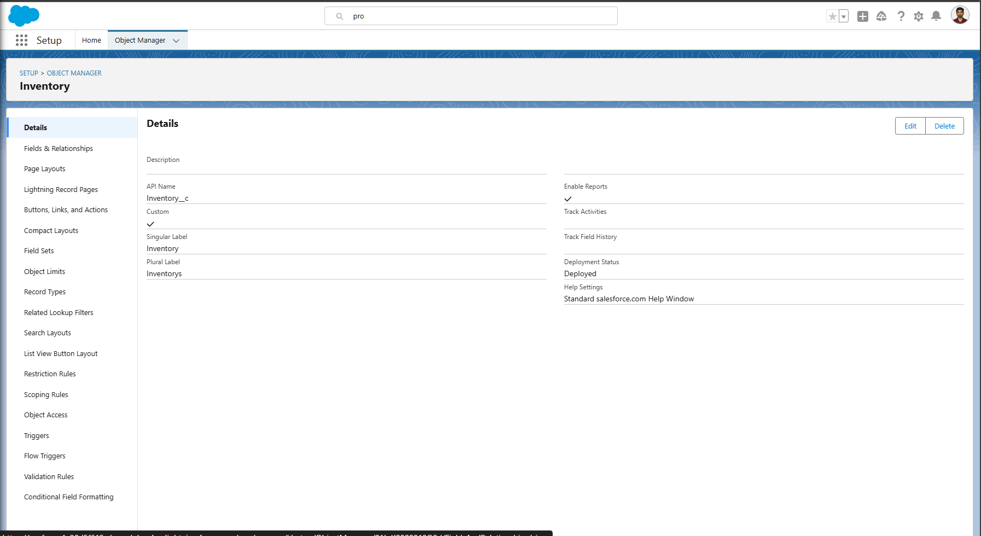

**5.5 Object - Marketing Campaign:-**

The Marketing_Campaign__c object is designed to track and manage promotional activities and targeted campaigns within the HandsMen Threads Salesforce CRM system. It enables the business to record outreach efforts, analyze campaign performance, and associate campaigns with specific customers.

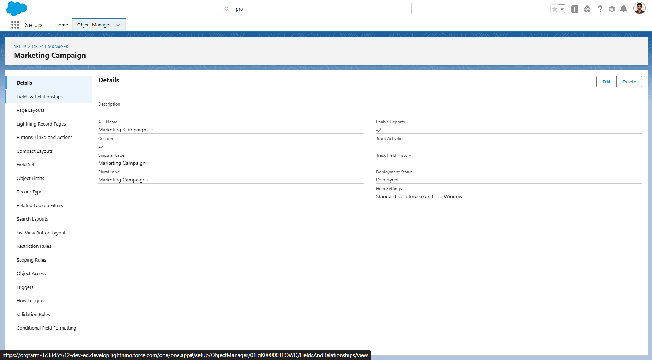

**6. Data Management – Fields**

Efficient field management was critical to ensure data accuracy, support automation, and enable reporting within the HandsMen Threads CRM system. Each custom object was enriched with standard fields (like Email and Phone), picklists, formulas, and lookup relationships to support business logic and user needs.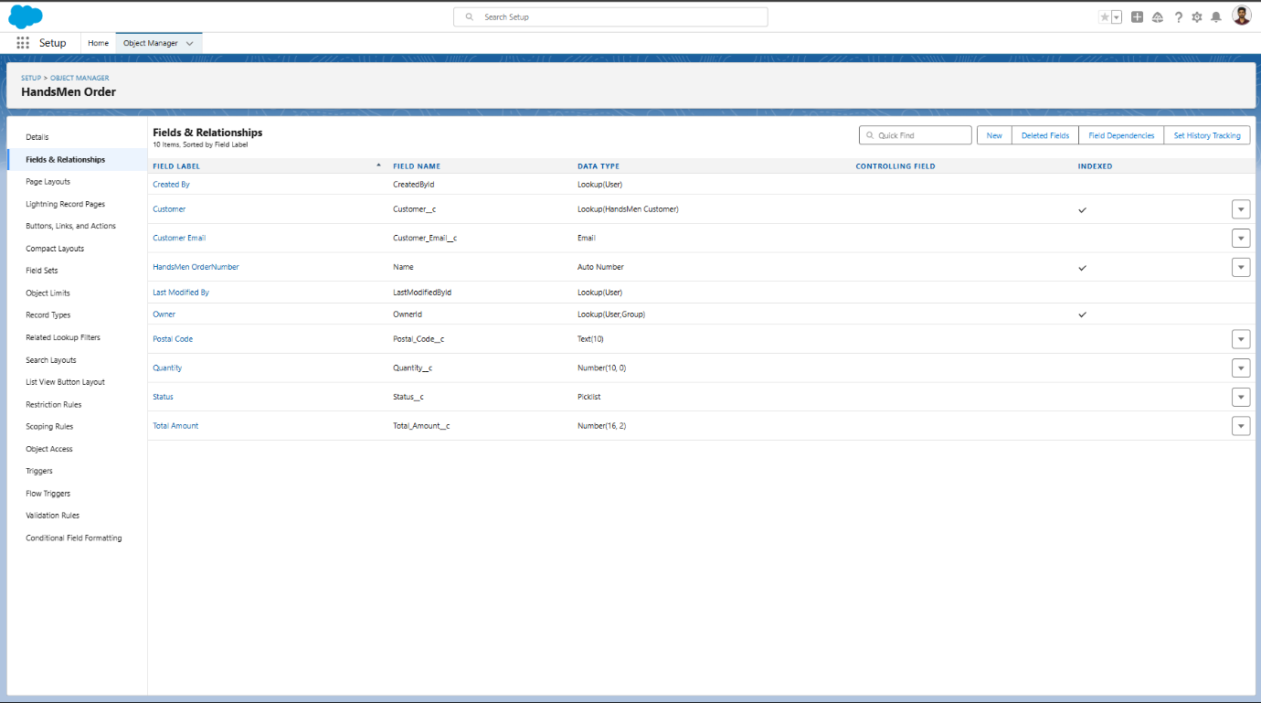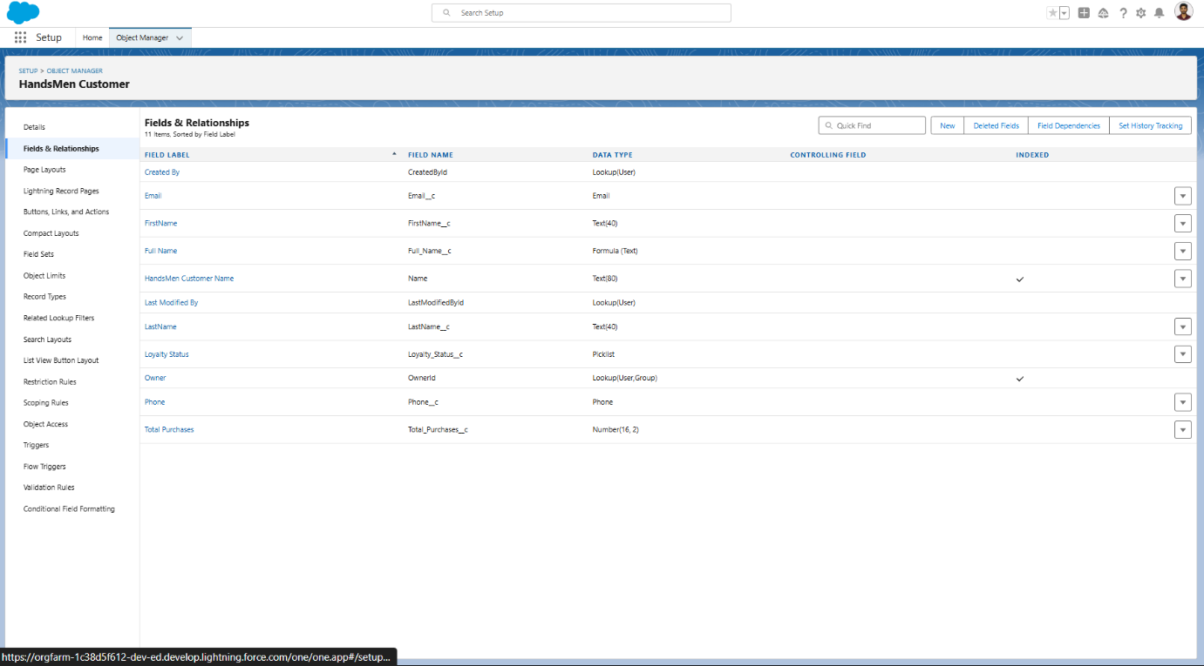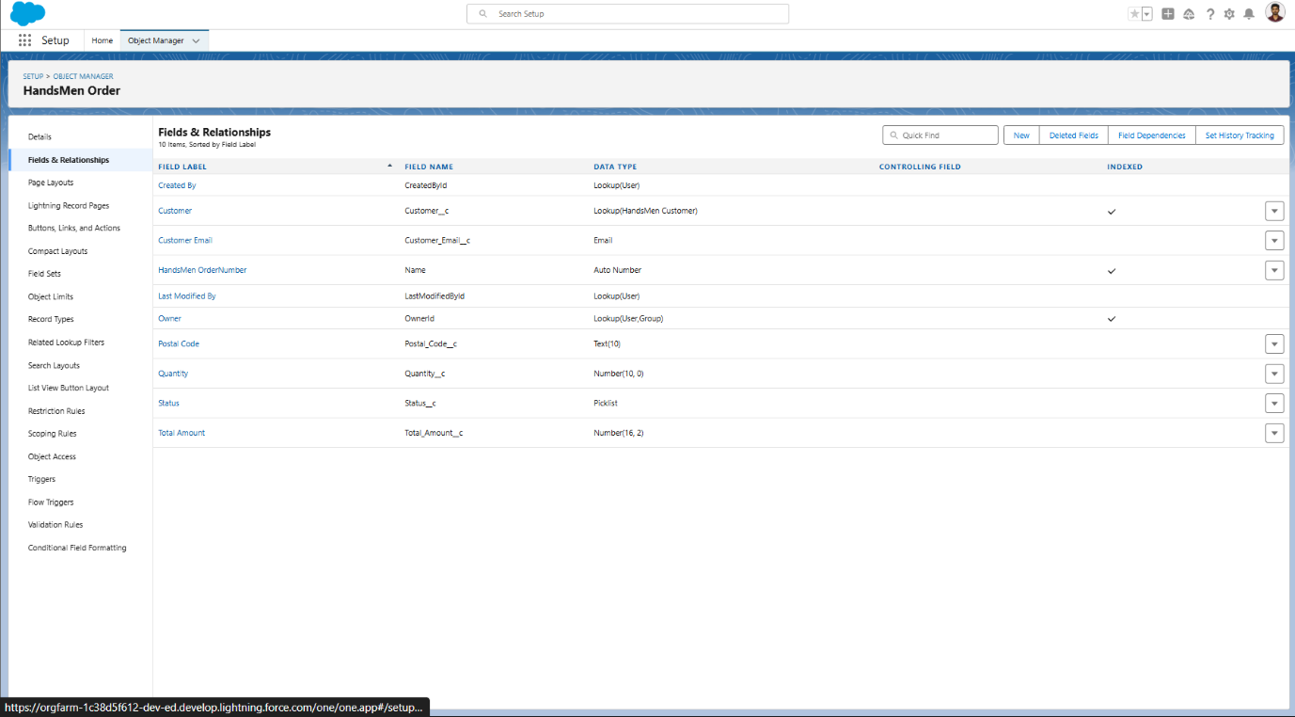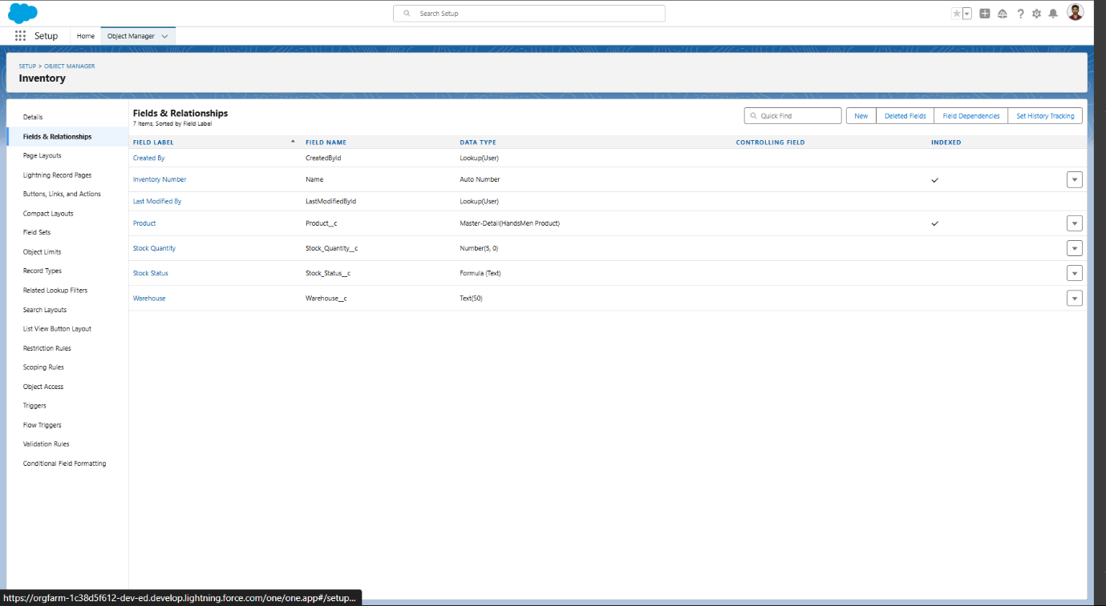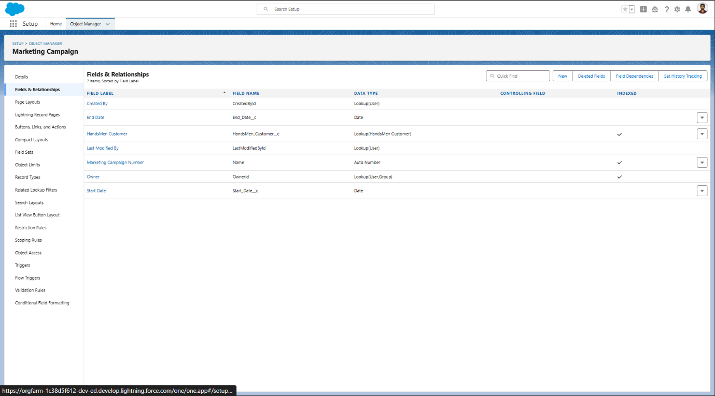

**7. Data Management - Tabs**

Tabs in Salesforce provide easy navigation and access to custom objects and data. For the HandsMen Threads CRM system, custom tabs were created for each key object to allow users to view, create, and manage records directly from the user interface.

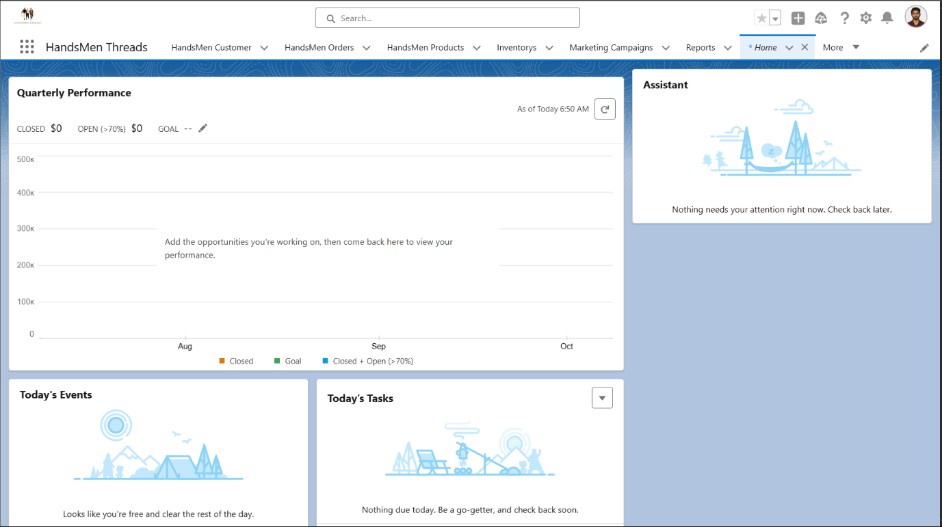

**8. Data Management - App Manager**

**App - HandsMen Threads**

As part of the Salesforce implementation for the HandsMen Threads project, a custom Lightning App named “HandsMen Threads” was created using the App Manager. This app centralizes all business objects, workflows, and dashboards into one streamlined workspace, allowing users to manage customers, orders, products, inventory, and marketing from a single interface.

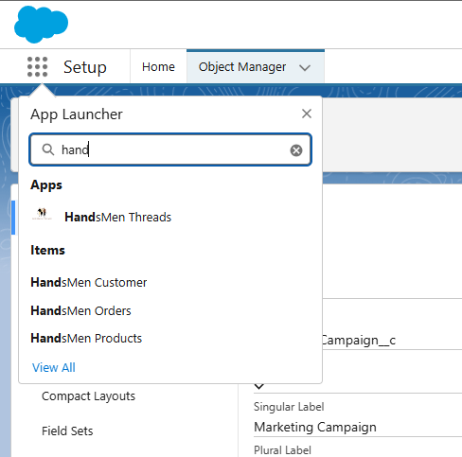

**9.Data Configuration**

Validation Rules were created to ensure the accuracy, completeness, and integrity of data entered into the system. These rules enforce business logic at the field level and prevent users from saving invalid or incomplete records.

**9.1Validation Rules**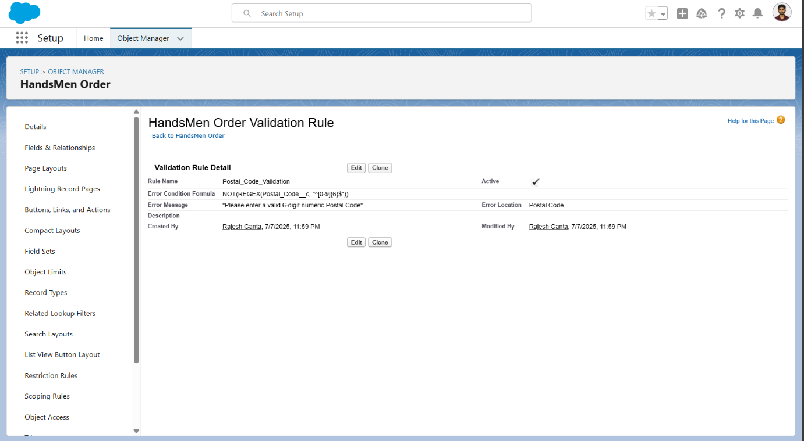

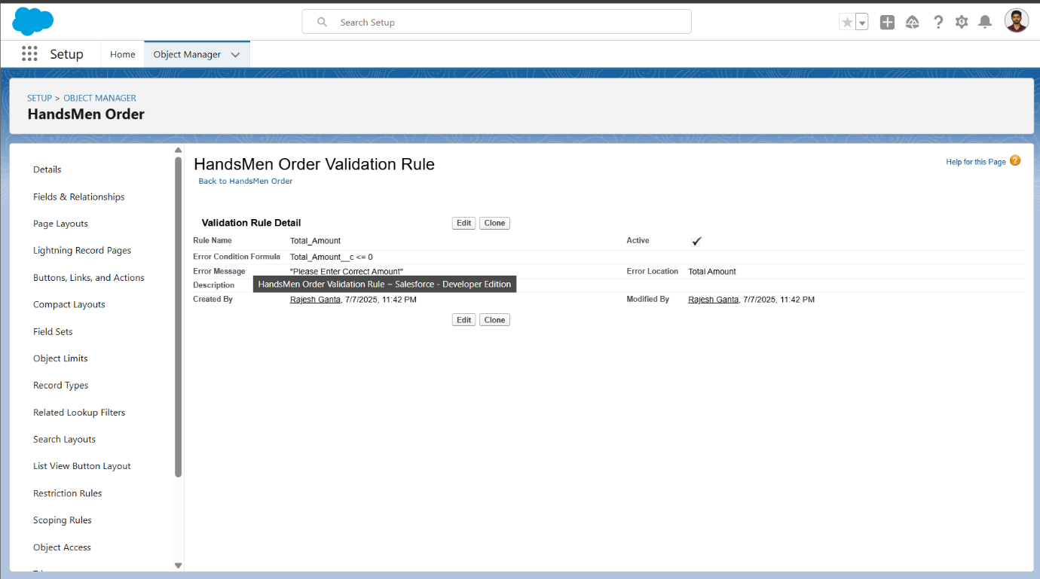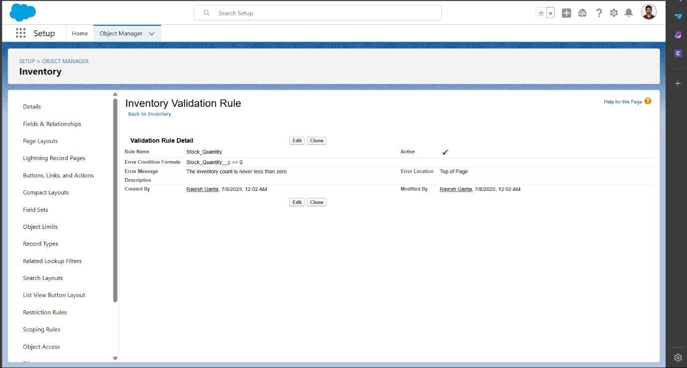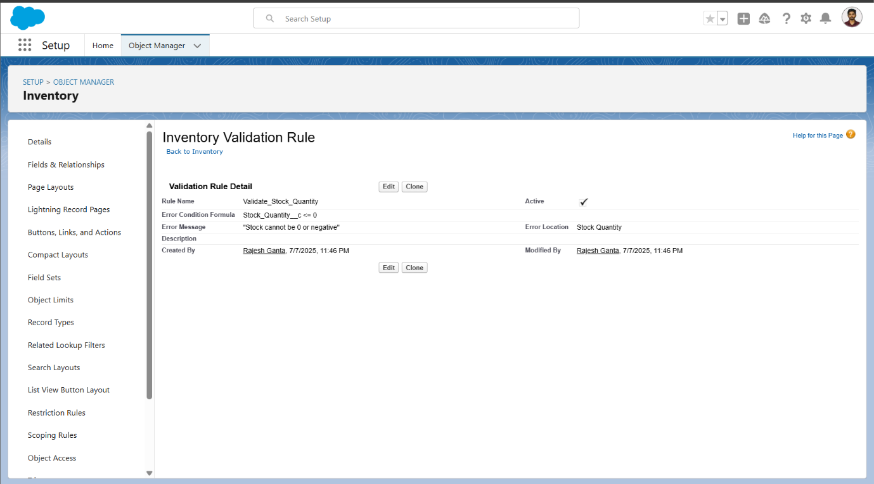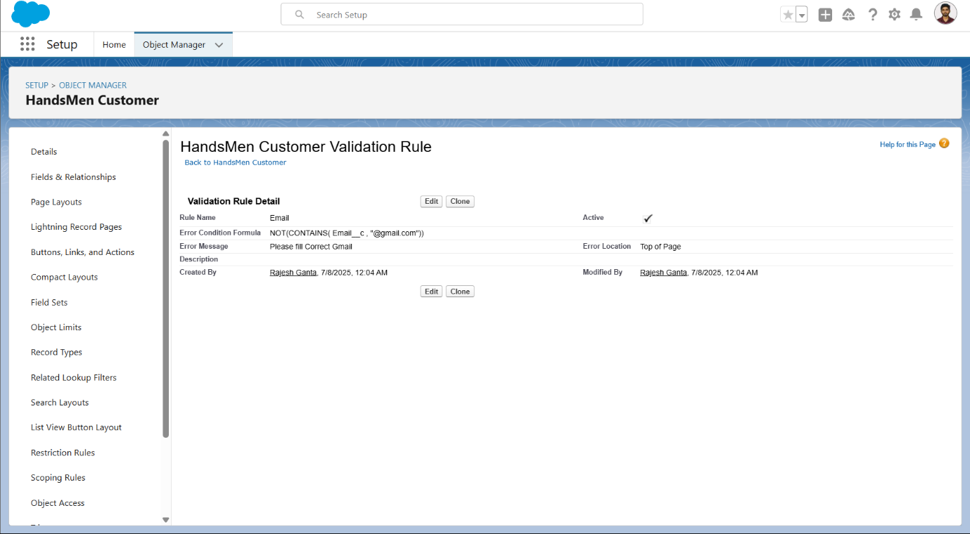

**10. Data security – Profiles**

Profiles in Salesforce control the level of access users have to objects, fields, tabs, and other platform features. For the HandsMen Threads CRM project, custom profiles were created to reflect different roles within the organization. This ensures users only see and interact with the data relevant to their responsibilities.

**Profile – Sales**

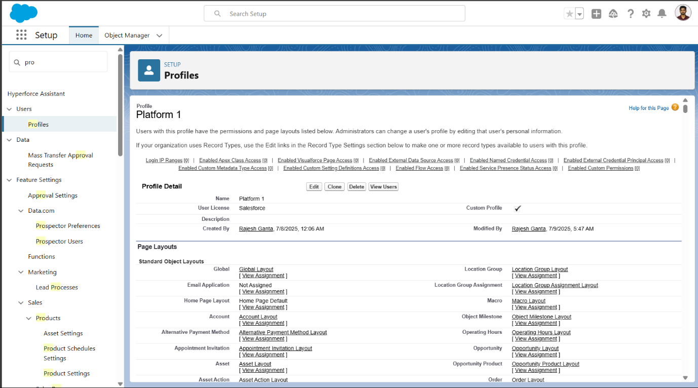

**11. Data Security – Roles**

Roles in Salesforce determine record-level access by controlling who can view, edit, or share records owned by other users in the hierarchy. For the HandsMen Threads CRM, roles were created to align with different departments like Sales, Inventory, Marketing, and Administration.

**Role - Sales**

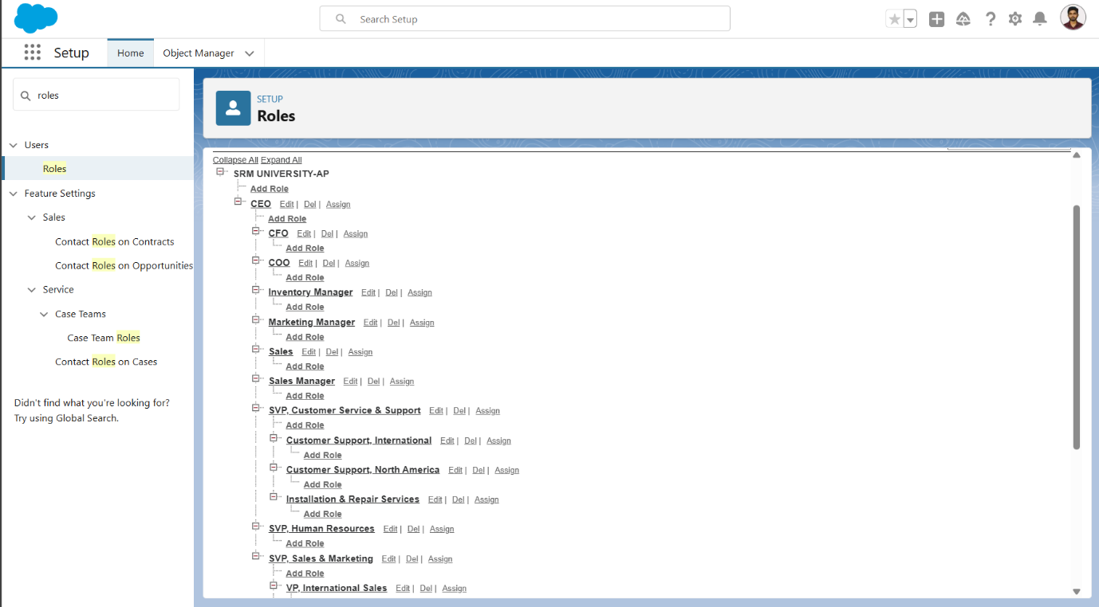

**12.Data Security – Users**

**In Salesforce, Users are individual accounts that represent real employees or team members accessing the CRM. Each user is assigned a Profile (for object-**level permissions) and a Role (for record-level access). Creating well-defined **users helps implement a secure, organized, and functional CRM system.**

**Users**

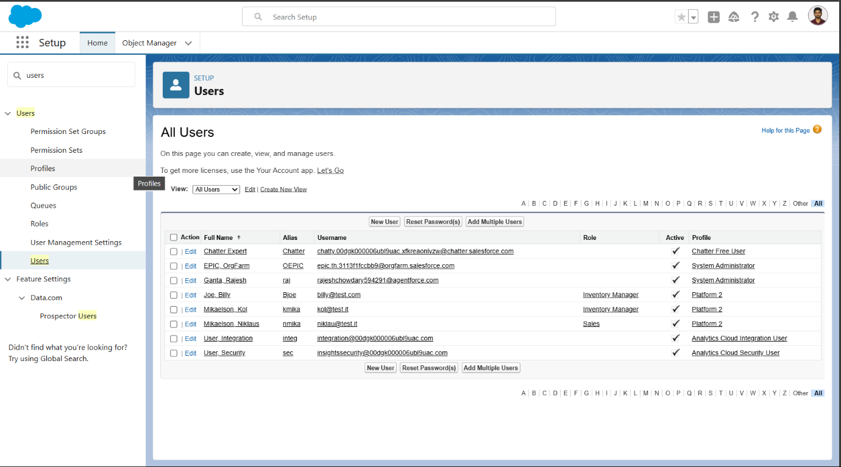

**13. Data Security - Permission Set**

**Permission Sets in Salesforce allow administrators to grant additional permissions to users without changing their profile. This is useful for providing flexible and scalable access to specific objects, fields, or functionalities that go beyond the default profile setup.**

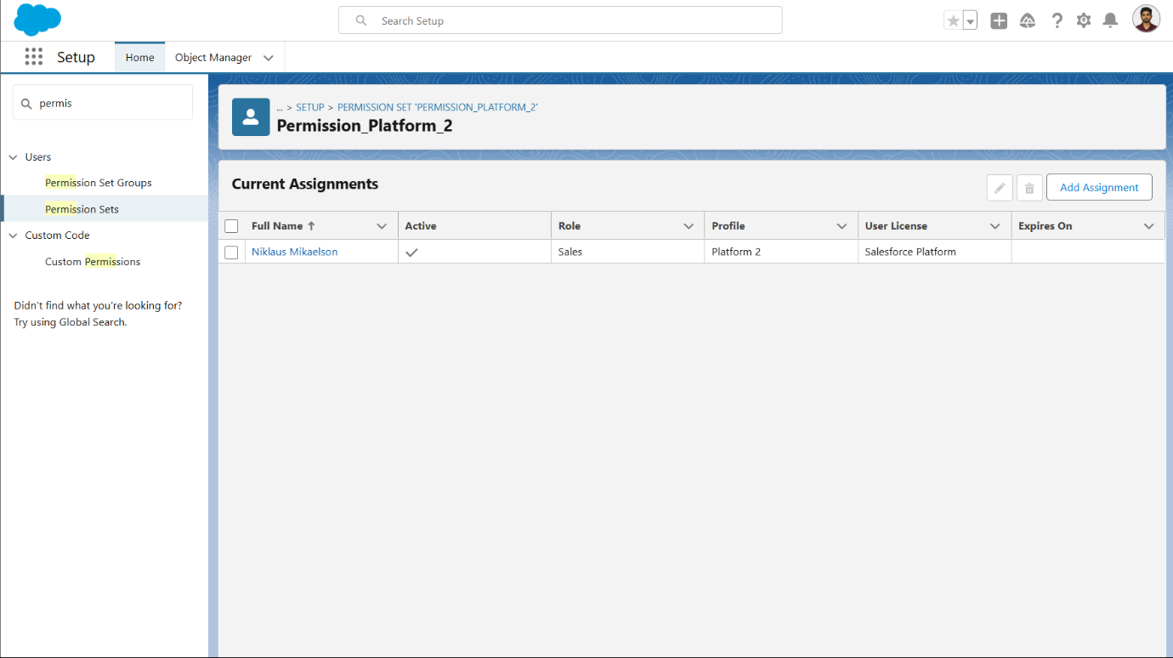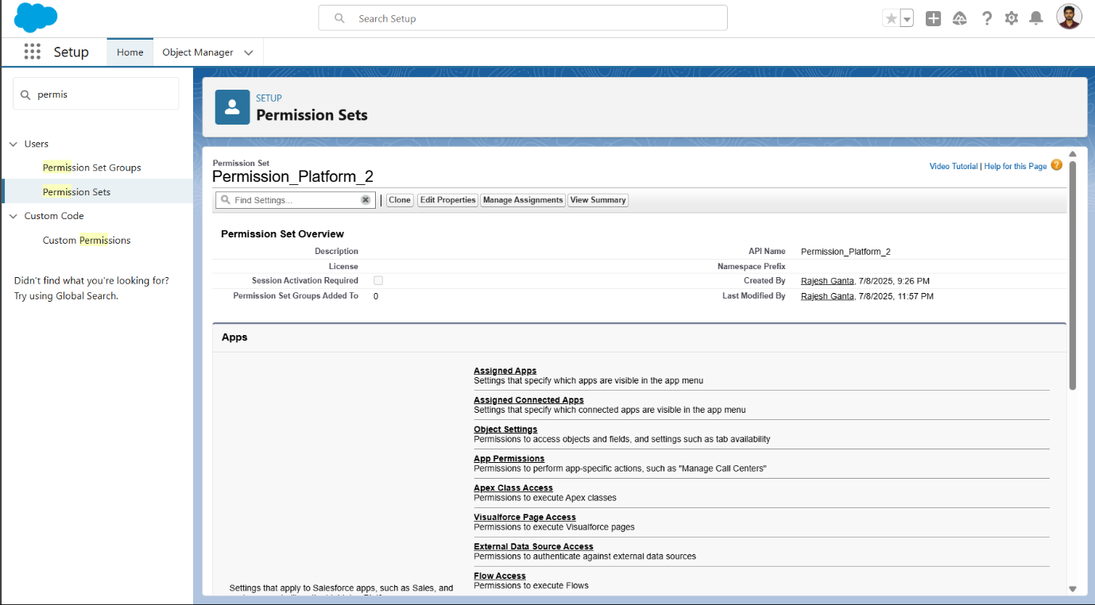

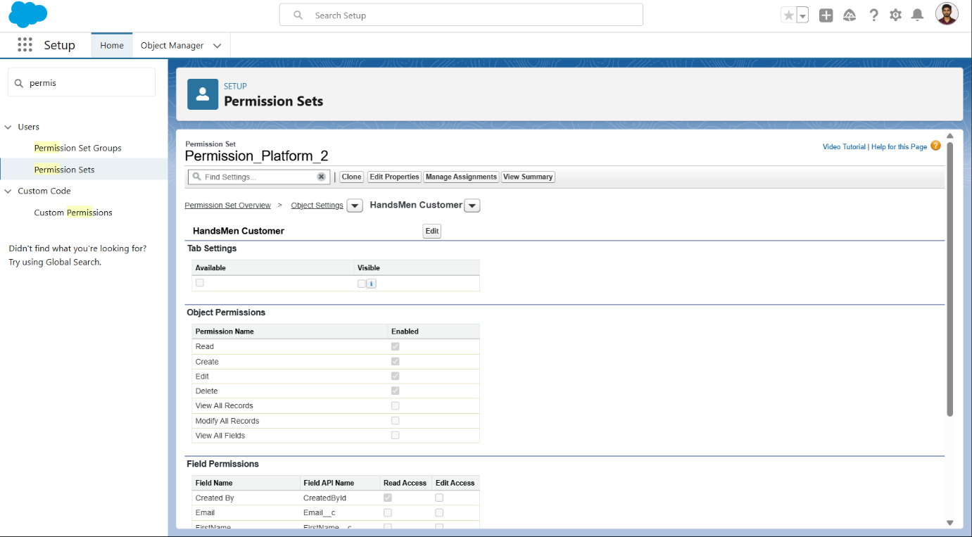

**14. Email Template**

Email templates in Salesforce are used to send automated, professional messages to customers and internal teams during key CRM events. For the HandsMen Threads CRM, email templates were created to support core automations such as order confirmations, stock alerts, and campaign updates.

**14.1 Create an Email Template**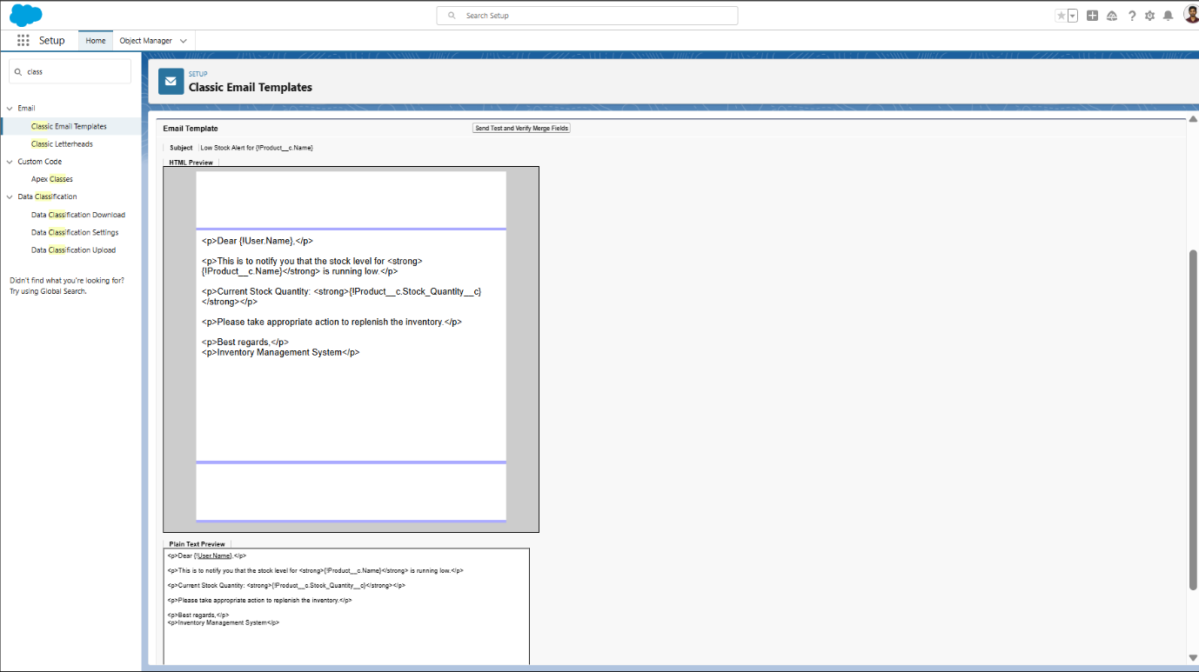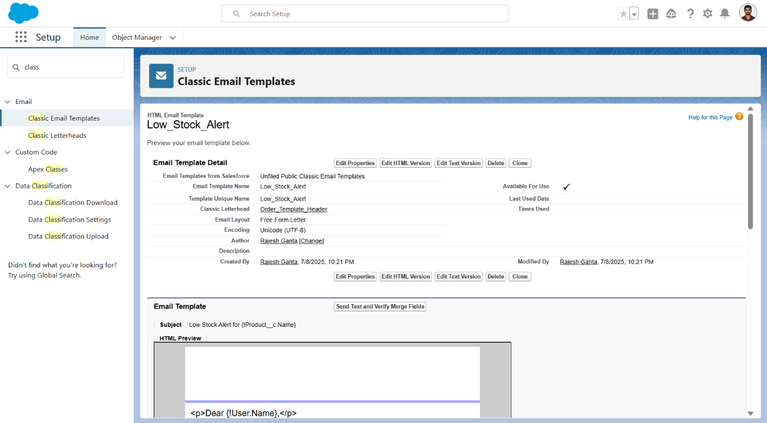

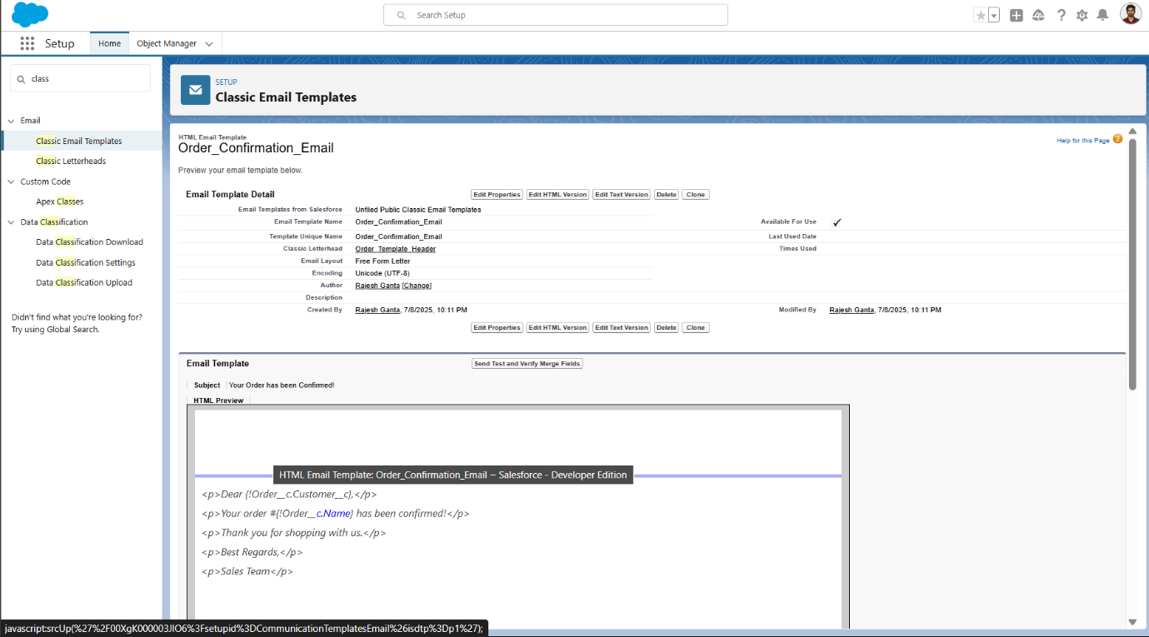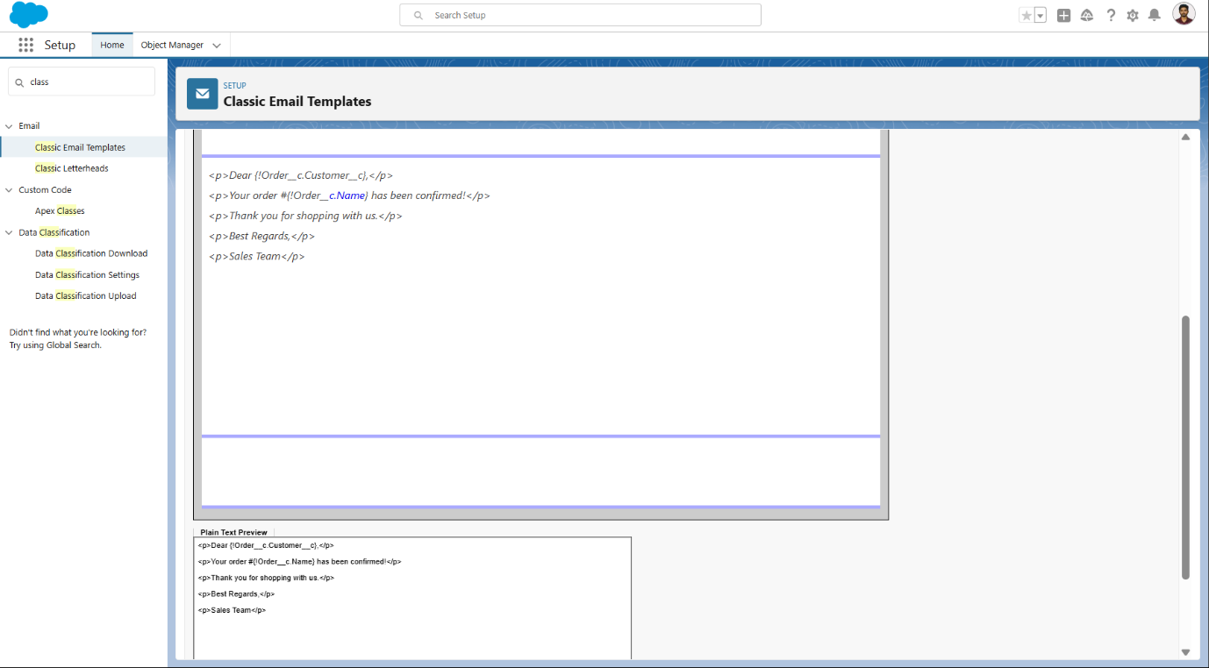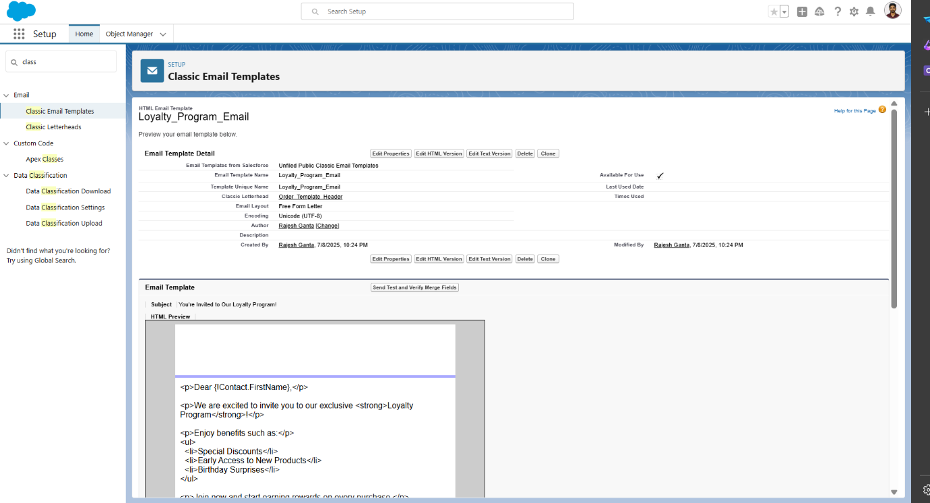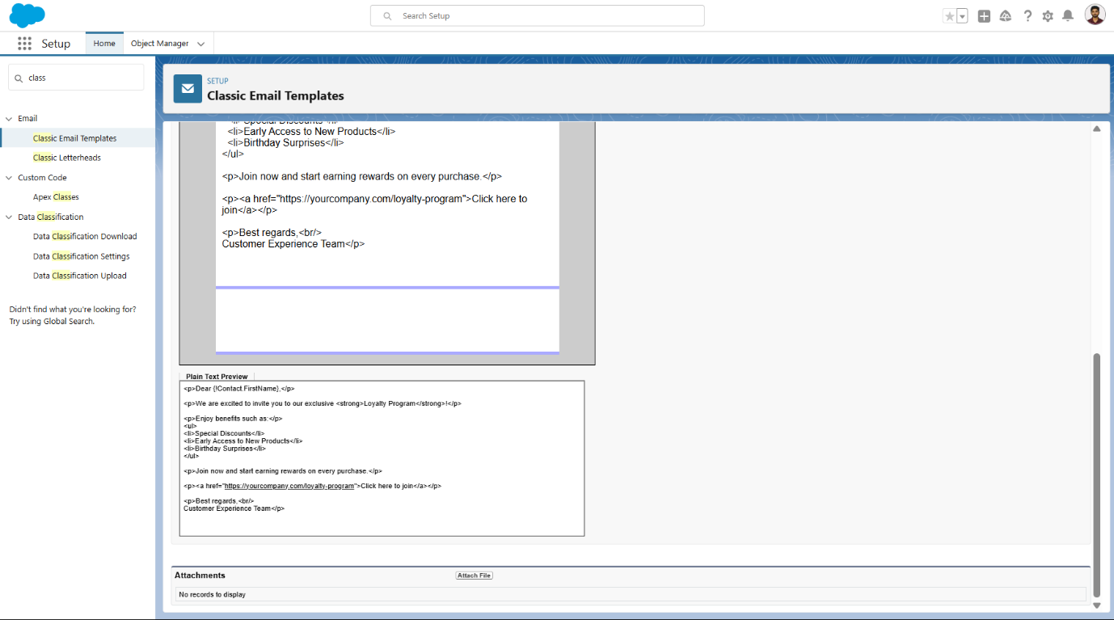

**14.2Create an Email Alert**

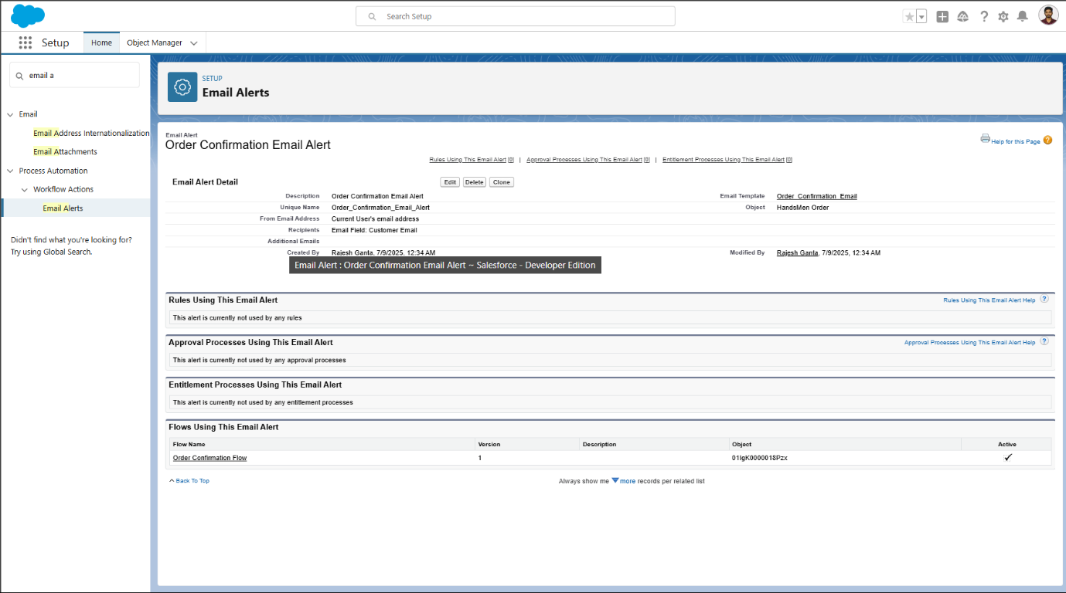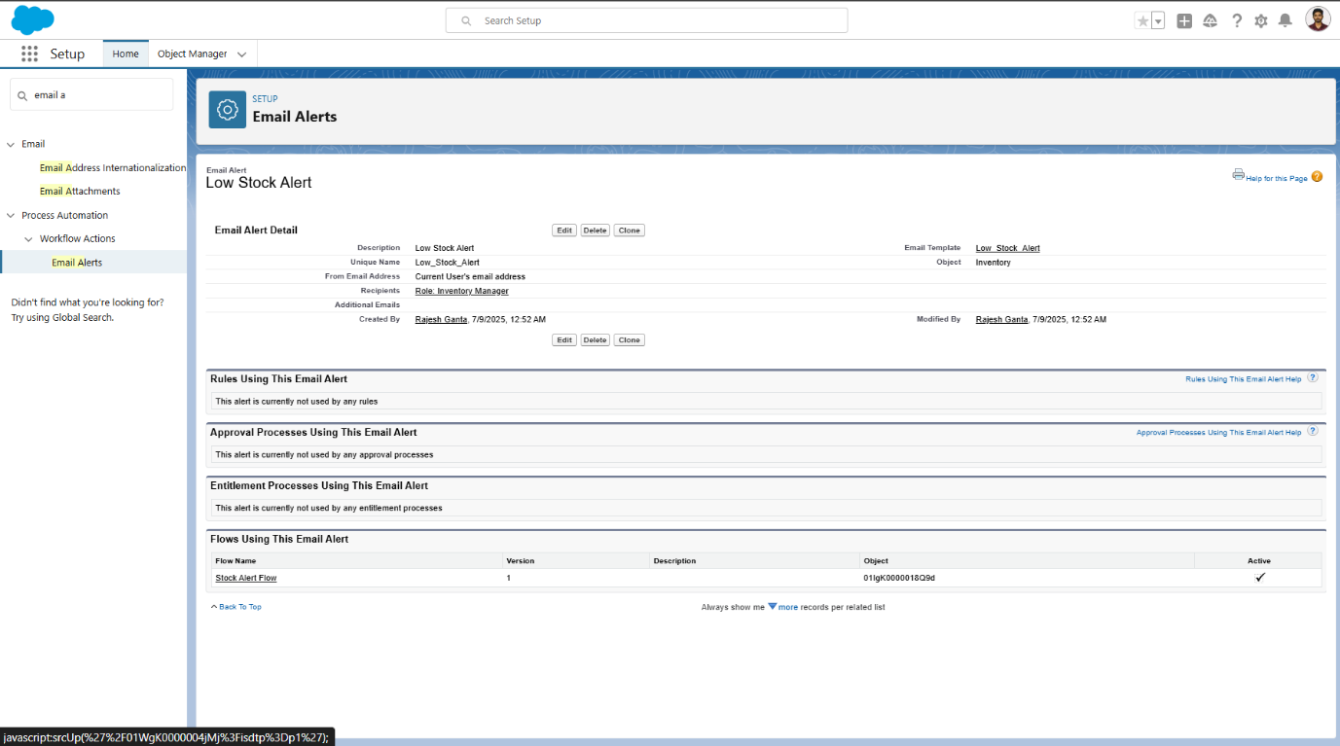

**15. Flows**

Flows in Salesforce are powerful no-code/low-code automation tools that allow teams to implement complex logic, data updates, and notifications. In the HandsMen Threads CRM system, flows were designed to automate tasks such as order confirmations, loyalty updates, stock alerts, and batch updates — all without user intervention.

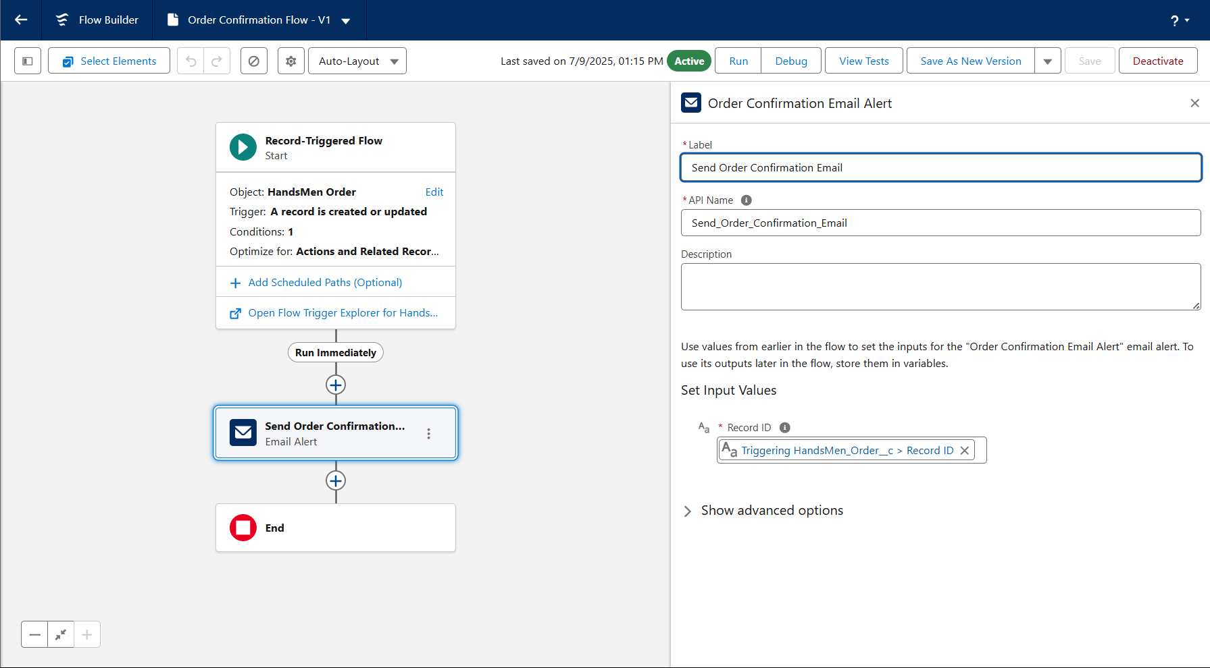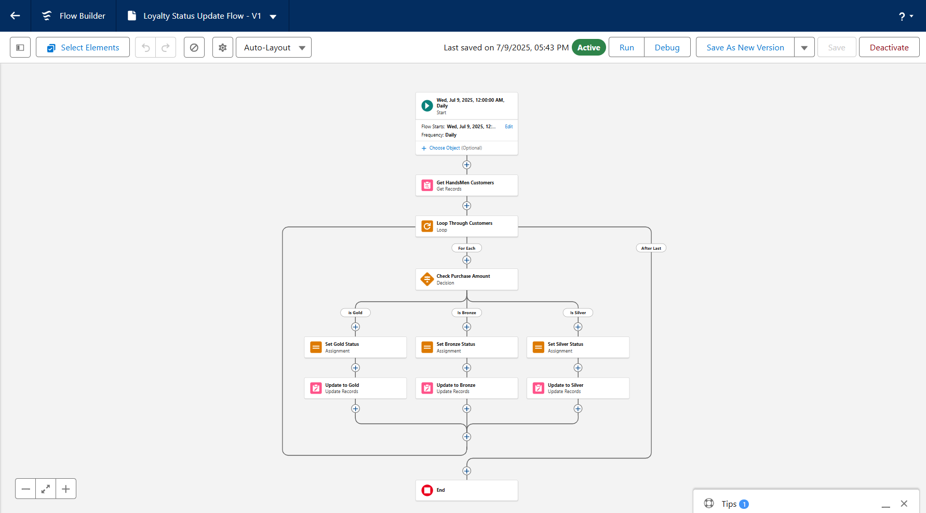

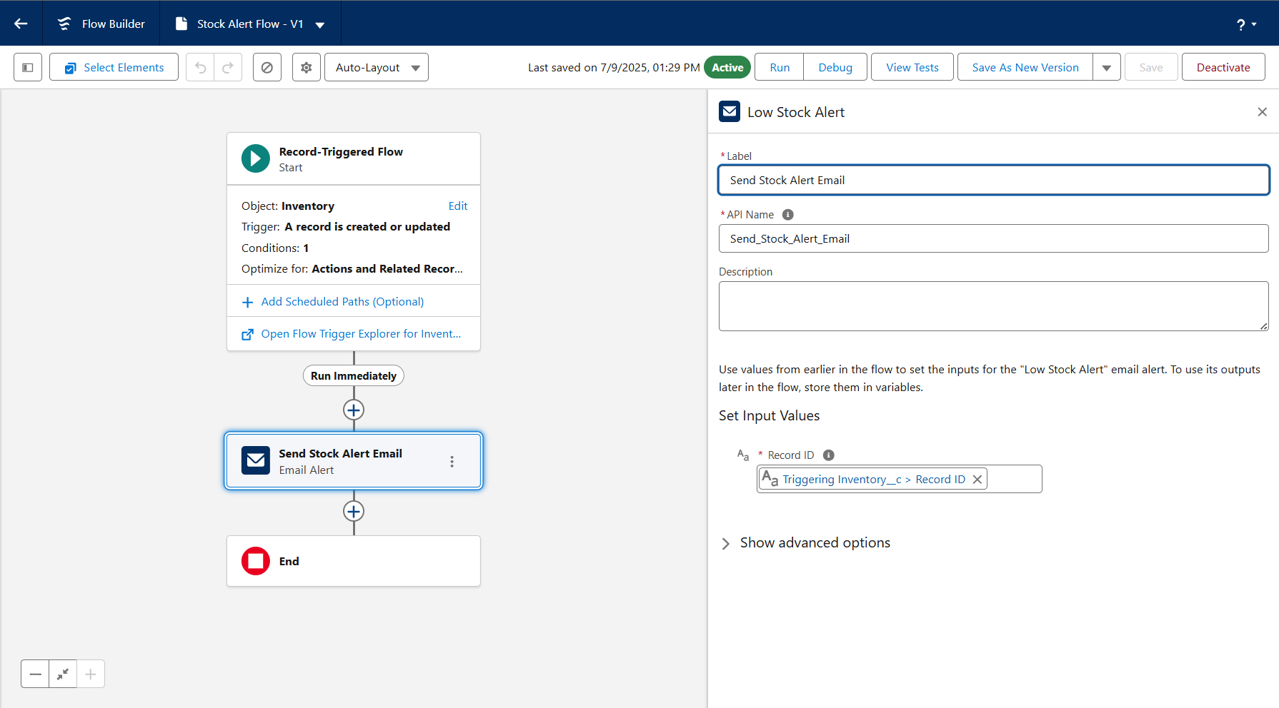

**16. Automation using Apex**

Apex code enables advanced automation and customization in Salesforce beyond what flows and process builders can handle. In the HandsMen Threads CRM system, Apex Triggers and Classes were developed to implement custom logic, especially for order management, inventory control, and loyalty updates.

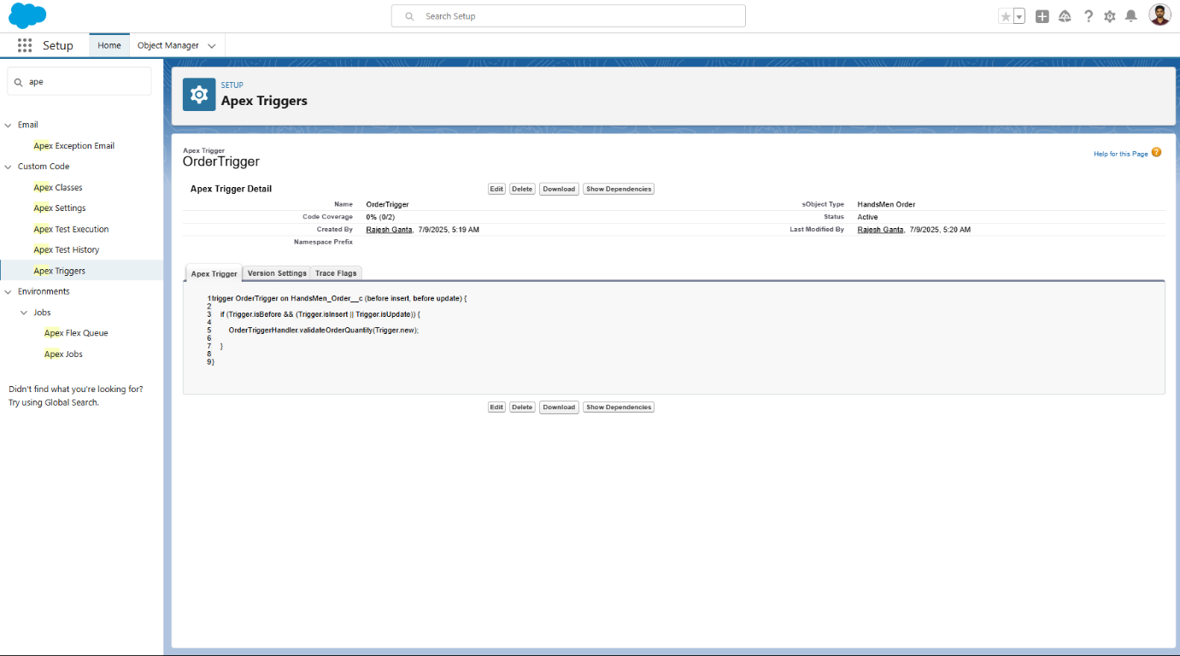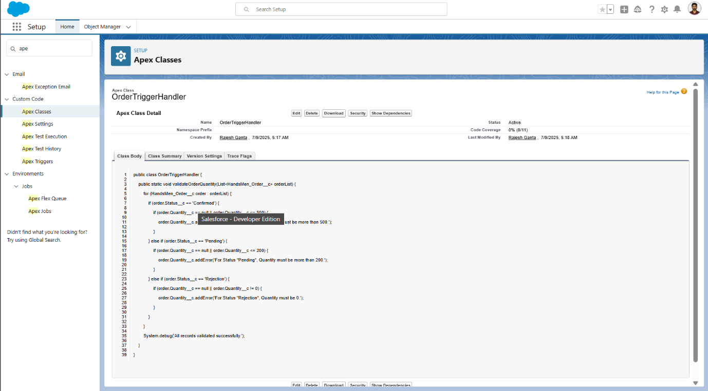

**17. Batch jobs**

Batch Apex in Salesforce is used for handling large volumes of data asynchronously. In the HandsMen Threads CRM, batch jobs were implemented to automate nightly updates, stock recalculations, and loyalty segmentation without impacting system performance.

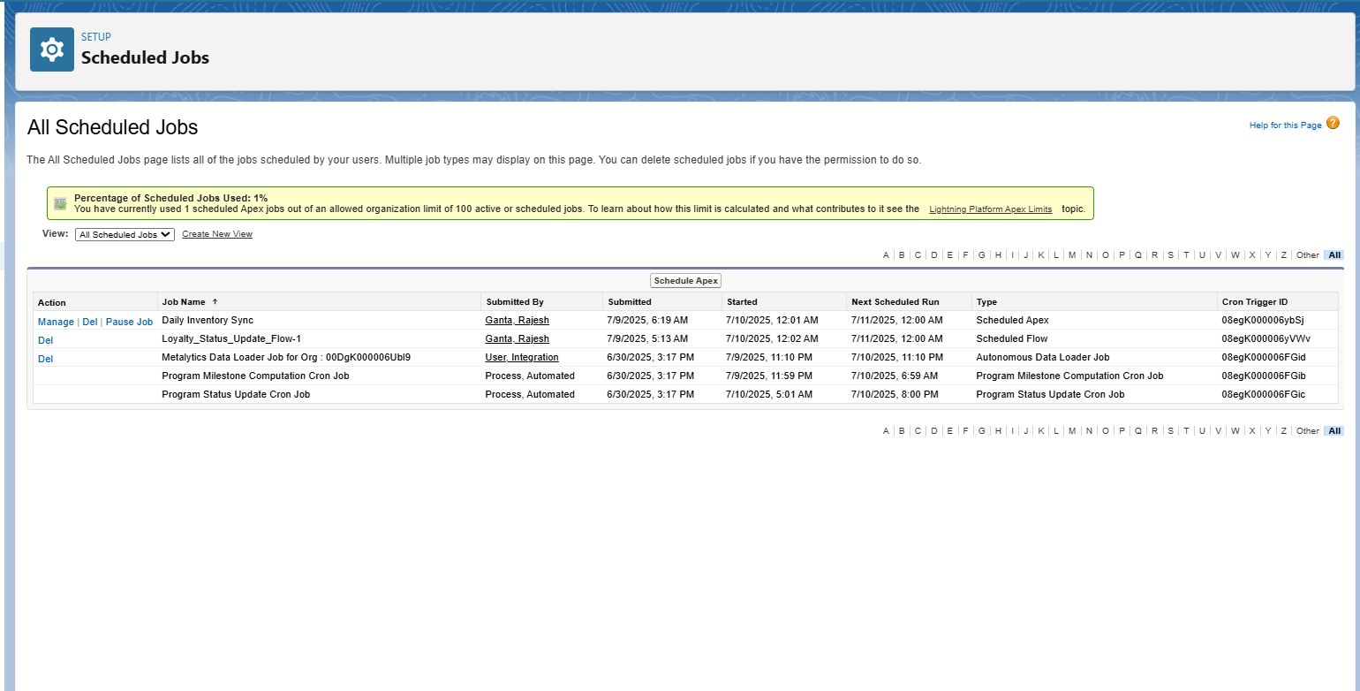

**18. Dashboard**

Dashboards in Salesforce visually represent your data through charts, tables, and metrics, enabling real-time insights into business performance. For the HandsMen Threads CRM system, a custom dashboard was created to monitor sales, customer engagement, product inventory, and marketing effectiveness.

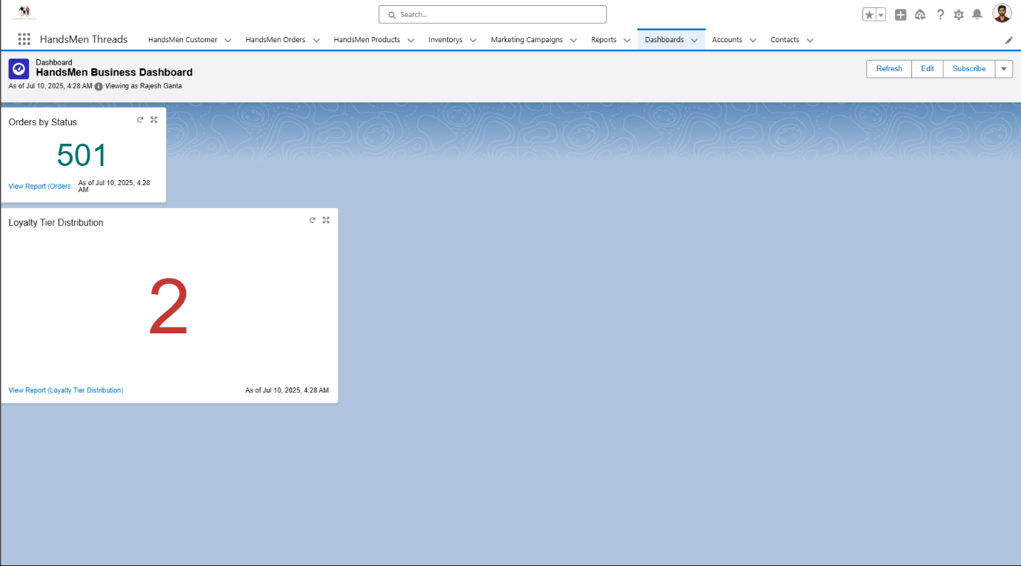

**19. Reports**

Reports in Salesforce help analyze key business data and make informed decisions. For the HandsMen Threads CRM project, custom report types and reports were created to track orders, customer loyalty, and product inventory**.**

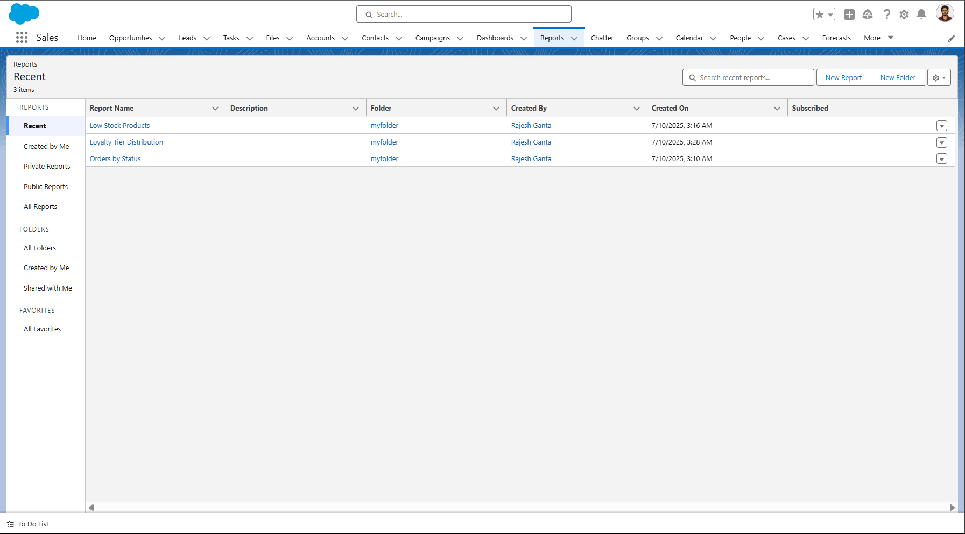

**20. Challenges & Learnings**

**Challenges Faced:**

* Understanding object relationships (Lookup vs Master-Detail).
* Creating correct access levels via role hierarchy.
* Debugging Apex logic and testing flows.

**Key Learnings:**

* Hands-on experience in Salesforce Admin and Developer capabilities.
* Implemented real-world use cases with automation tools.
* Improved problem-solving using flows and custom logic.

**21. Tools & Technologies Used**

* Salesforce Lightning Experience
* Apex Programming
* Flow Builder
* SOQL / SOSL
* Data Loader
* Report & Dashboard Builder

**22.conculsion**

Throughout the project, a fully customized Salesforce platform was designed and implemented to streamline core business operations for a premium men’s fashion brand. Key modules such as customer management, order processing, inventory tracking, loyalty programs, and marketing campaigns were modeled using standard and custom objects, supported by automation tools like Flows, Apex Triggers, and Batch Jobs.

Interactive Reports and Dashboards were also built to provide real-time insights into sales performance, customer segmentation, and stock status—empowering decision-makers with accurate and timely data.

This project enhanced technical skills in:

* Salesforce Object Model Design
* Declarative Automation (Flows, Email Alerts)
* Programmatic Logic (Apex, Triggers, Batch Apex)
* Data Security (Roles, Profiles, Permission Sets)
* Analytics (Custom Reports and Dashboards)

**23. References**

1. Salesforce Trailhead  
   [*https://trailhead.salesforce.com*](https://trailhead.salesforce.com)  
   Used for understanding concepts like custom objects, flows, Apex triggers, dashboards, and security models.
2. Salesforce Help Documentation  
   [*https://help.salesforce.com*](https://help.salesforce.com)  
   Referred for technical configurations, Flow builder logic, report customization, and batch job scheduling.
3. SmartBridge Salesforce Internship Materials  
   Project-specific guidance and tasks were provided by the SmartBridge team during the internship.
4. Apex Developer Guide  
   [*https://developer.salesforce.com/docs/atlas.en-us.apexcode.meta/apexcode/*](https://developer.salesforce.com/docs/atlas.en-us.apexcode.meta/apexcode/)  
   For writing and testing Apex classes, triggers, and batch jobs.
5. Salesforce Admin Guide  
   [*https://admin.salesforce.com*](https://admin.salesforce.com)  
   Helped with setting up profiles, permission sets, page layouts, and app management.
6. Mentorship and Faculty Support  
   Guidance and feedback from mentors at SmartBridge.